# The British college

Admin interface

## Table of contents

**Log in……………………………………………………………………………………………………………. 2**

**Dashboard……………………………………………………………………………………………………. 2-3**

**Shop…………………………………………………………………………………………………………….. 4-5**

**Product………………………………………………………………………………………………………… 6-7**

**User……………………………………………………………………………………………………………… 8-10**

**Review…………………………………………………………………………………………………………. 10-11**

**Sign out………………………………………………………………………………………………………… 12**

# Log In

**Invalid admin login**

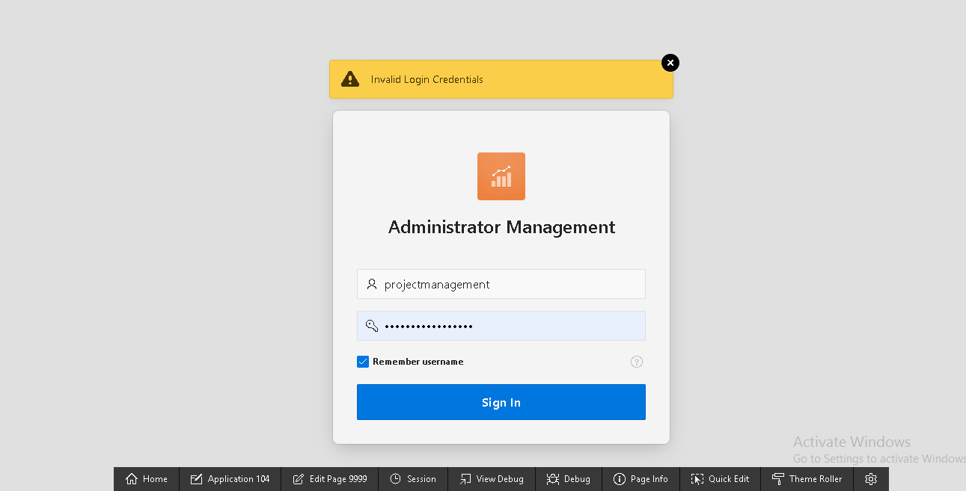

“Invalid Login credentials” message is displayed

**Dashboard**

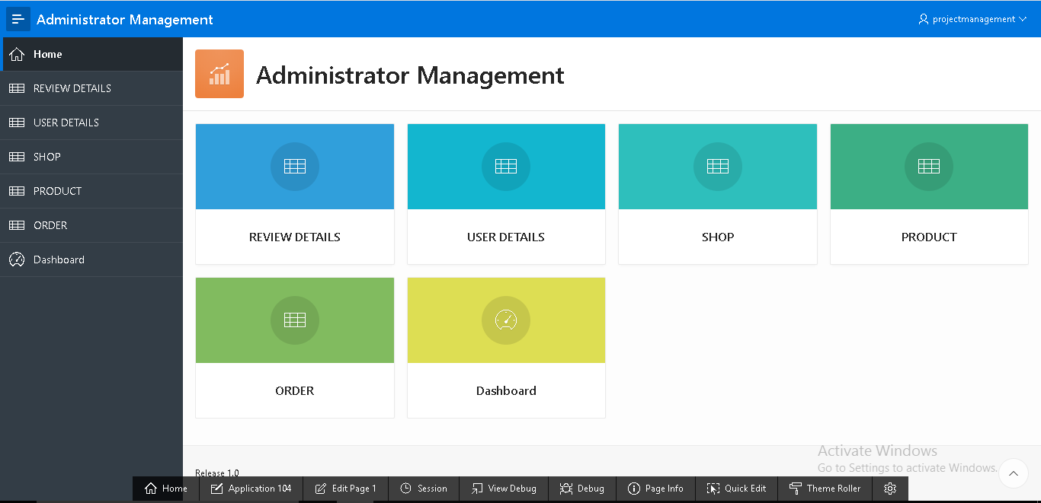

All the details of administration management has been shown

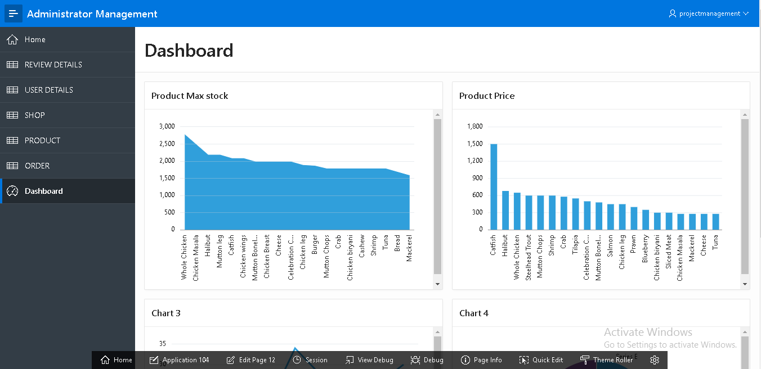

Product max stock and product price shown in chart

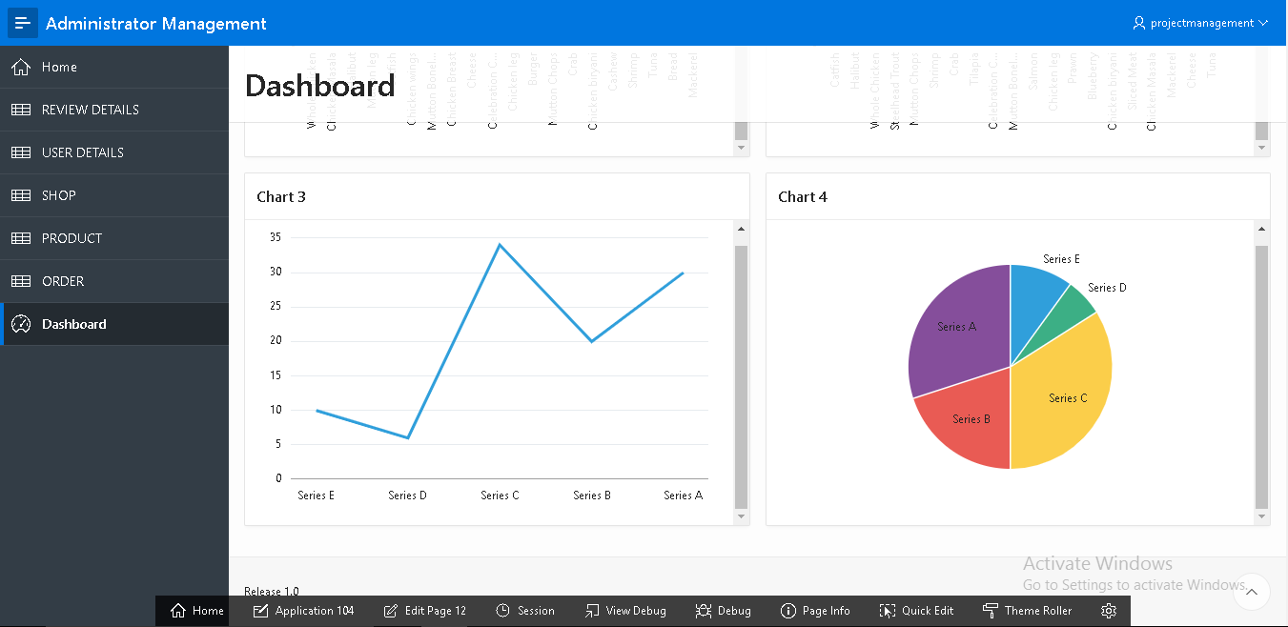

Details are shown in terms of chart

**Shop**

**Empty shop fields**

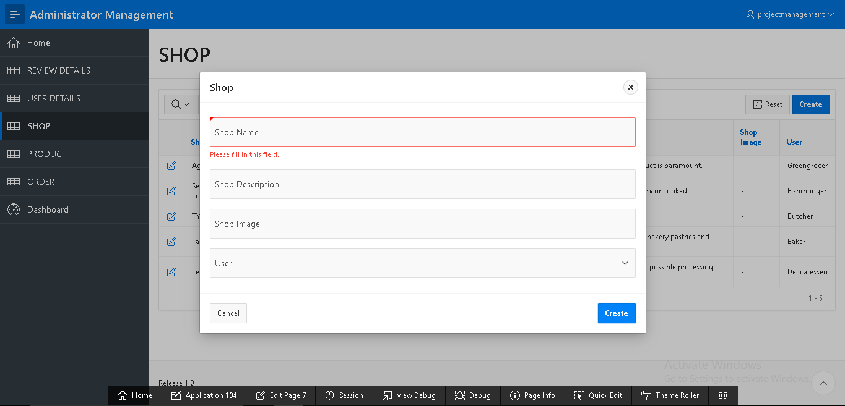

“Please fill in this field” message is displayed

**Insert shop form**

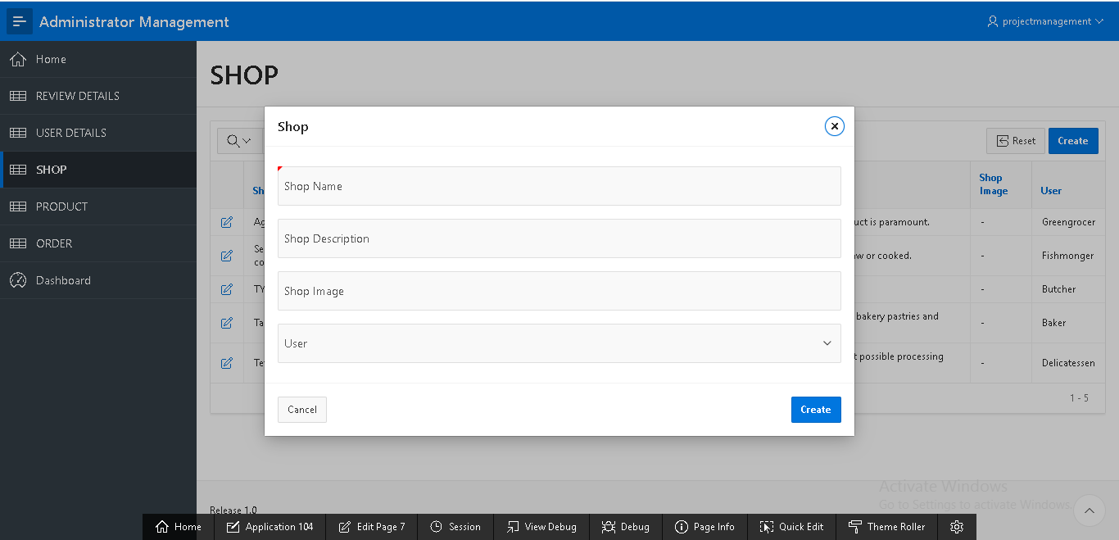

Shop form has been created

**Update shop**

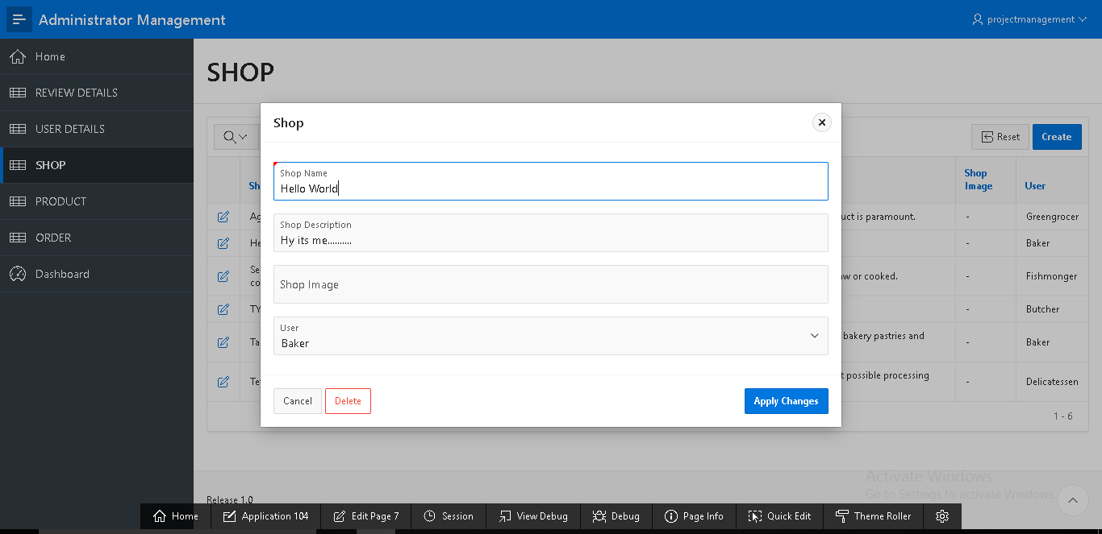

By clicking on “Apply changes” shop can be updated

**Delete shop**

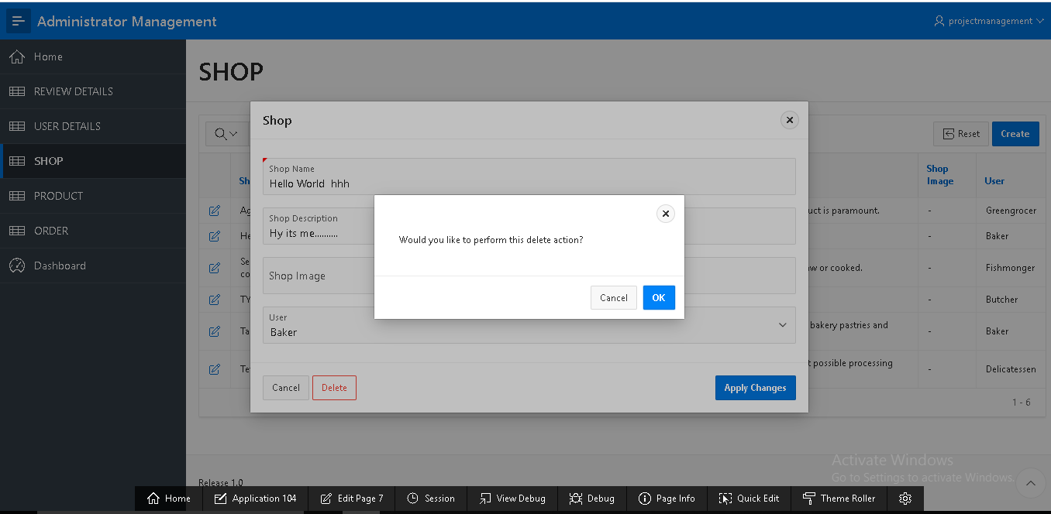

By clicking on “ok” button shop can be deleted

**Products**

**Empty product fields**

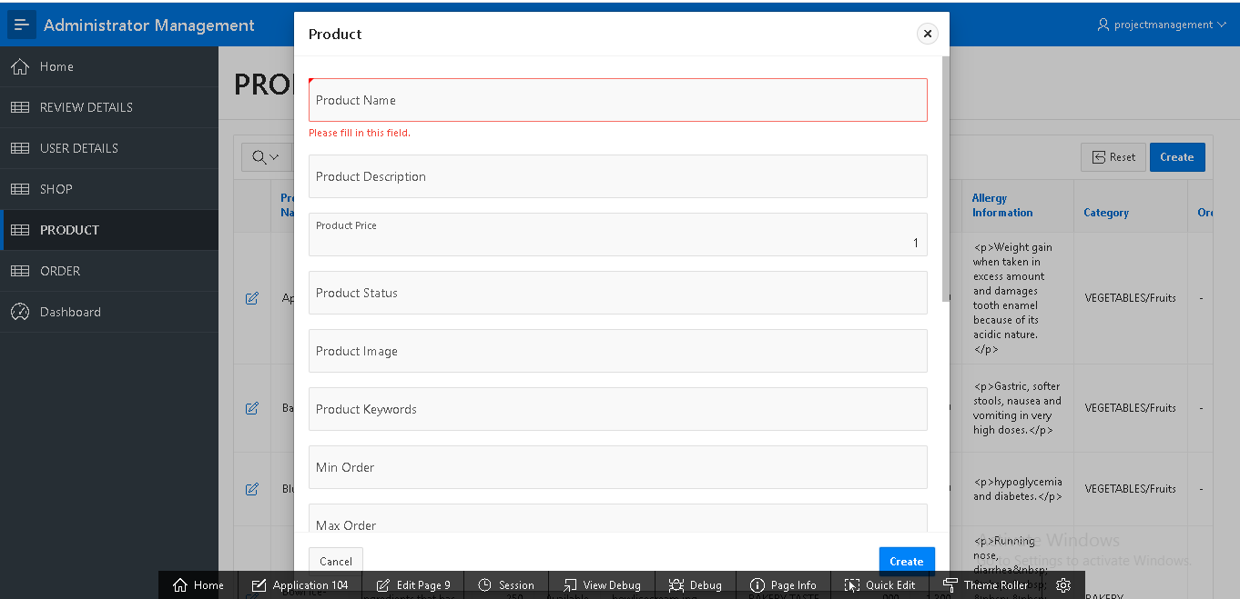

“Please fill in this field” message is displayed

**Insert product**

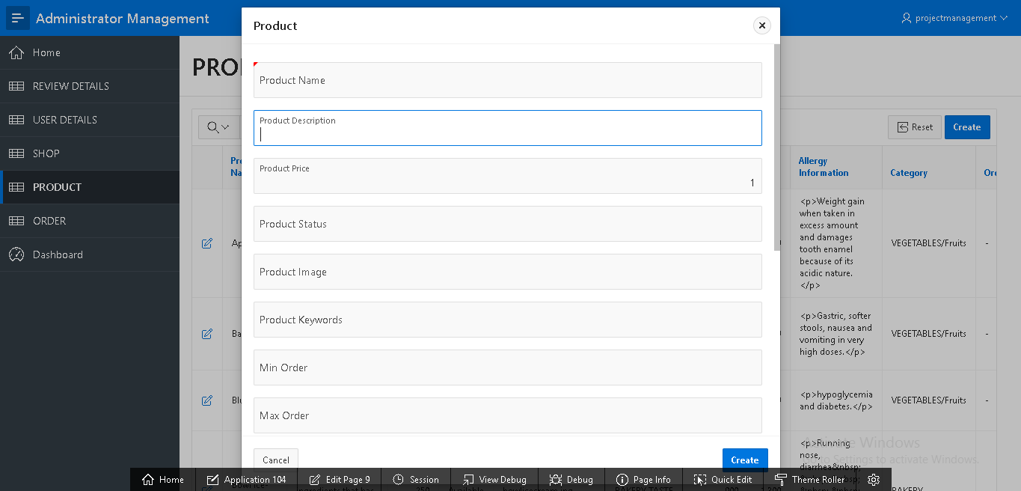 By filling this form product can be inserted

**Update product**

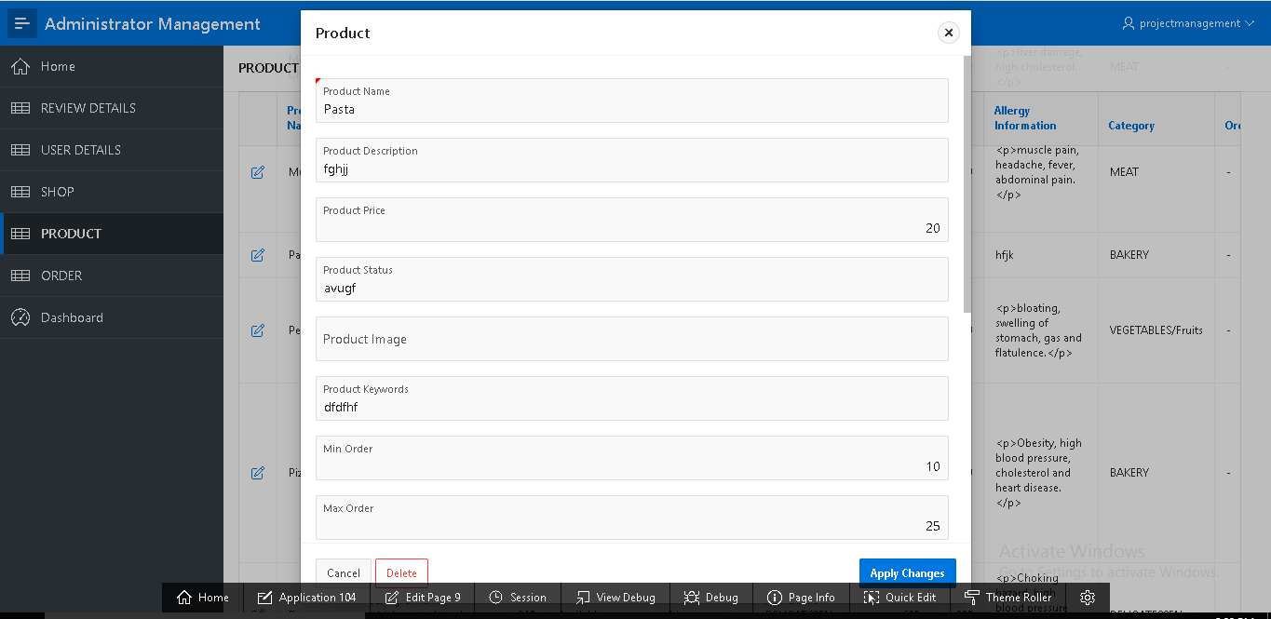

By clicking on “Apply changes” products can be updated

**Delete Product**

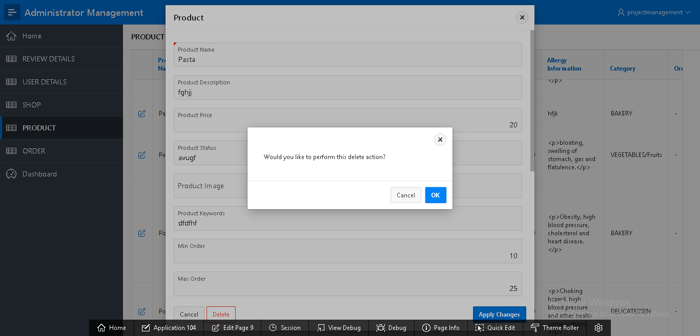

By clicking on “ok” products can be deleted

**User**

**Empty user field**

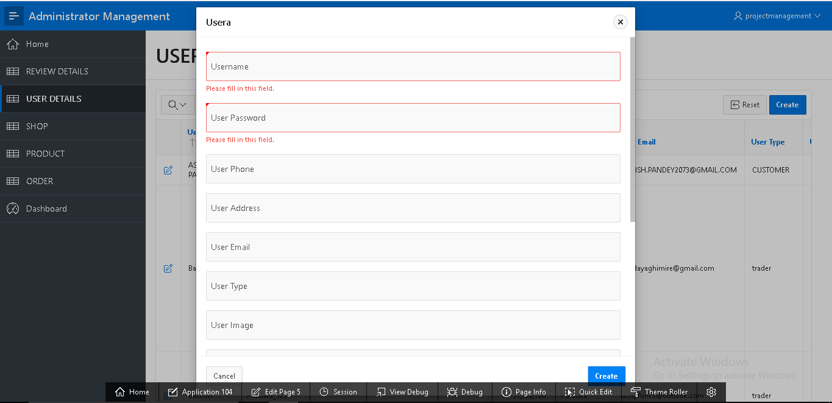

“Please fill in this field” message is displayed

**Insert user**

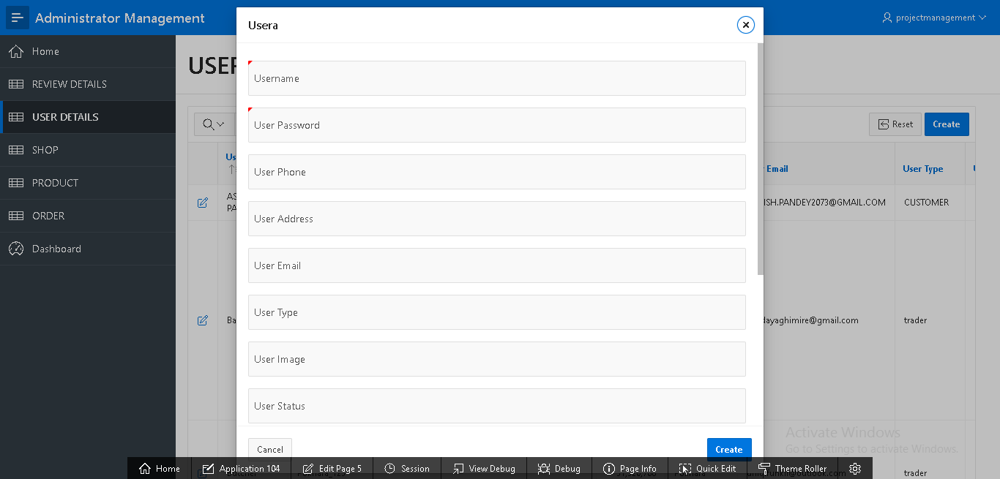

By filling this empty fields and clicking on “create” user can be inserted

**Update user**

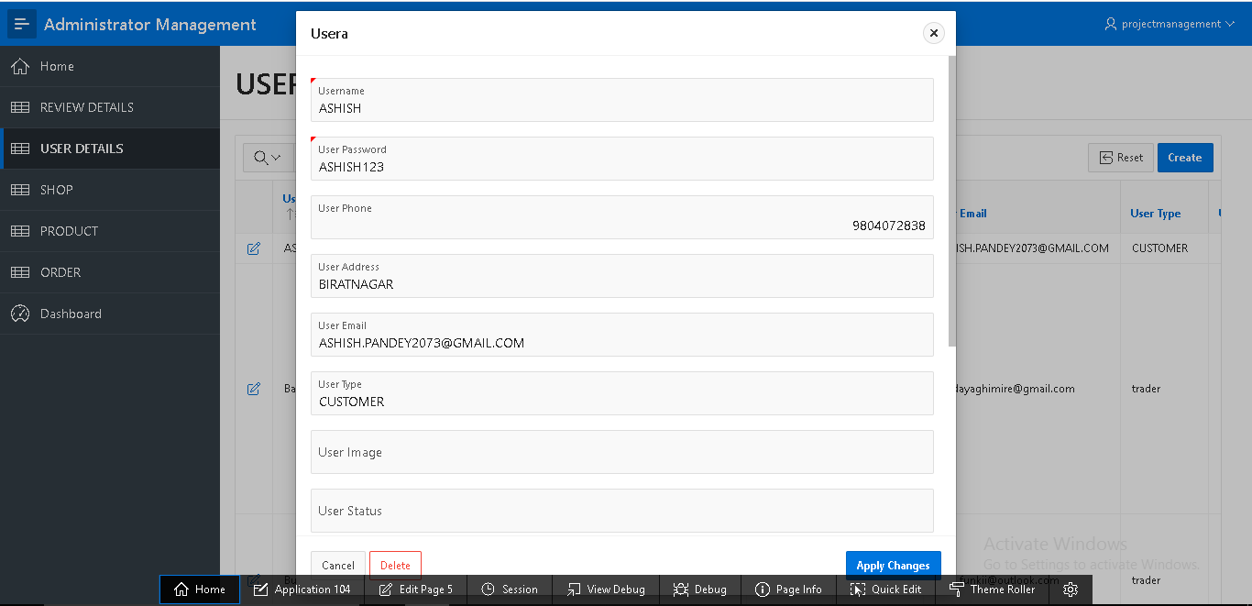

By clicking on “Apply changes” user can be updated

**Delete user**

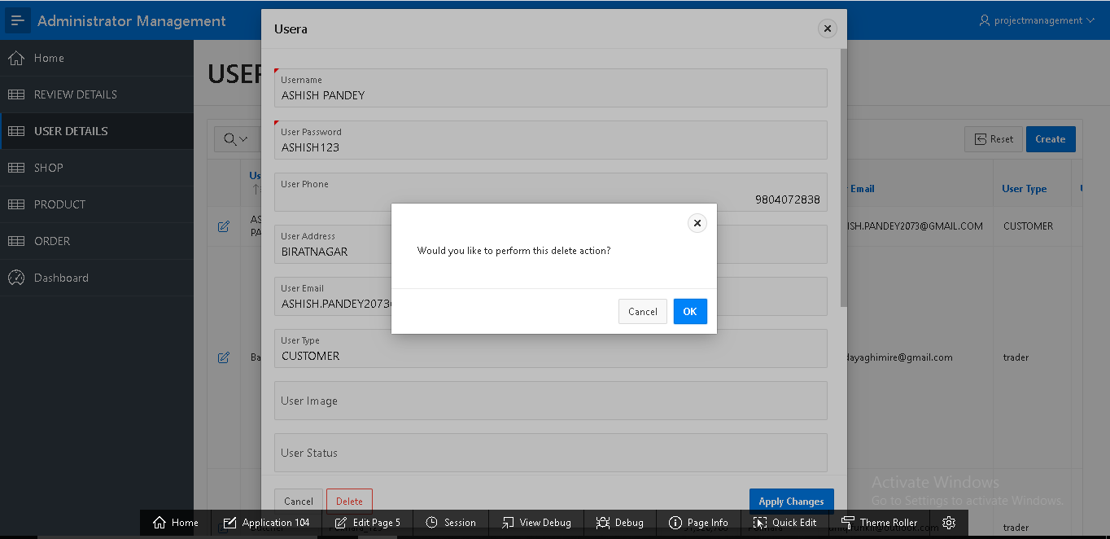

By clicking on “ok” user can be deleted

**User detail**

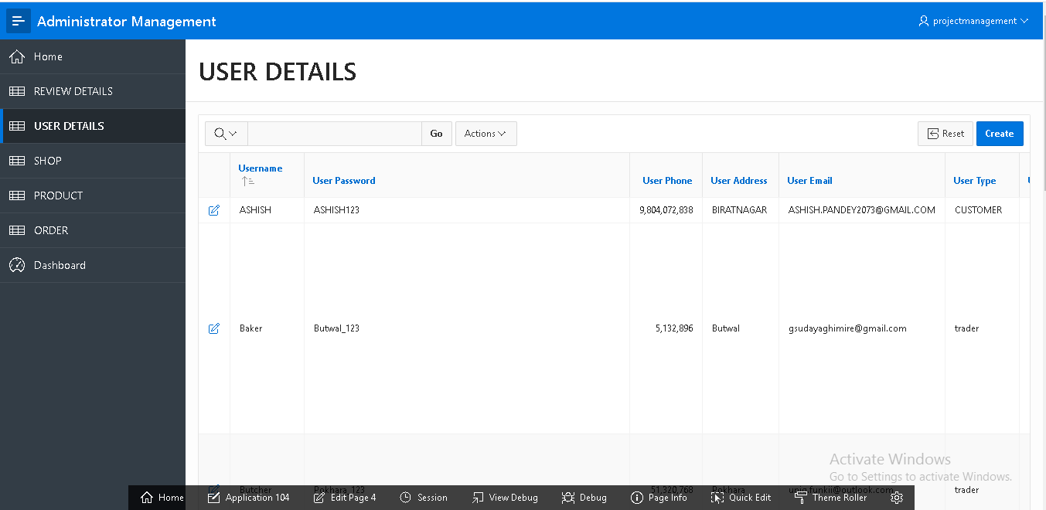

List of all user with their personal information are shown

**Review**

**Insert review form**

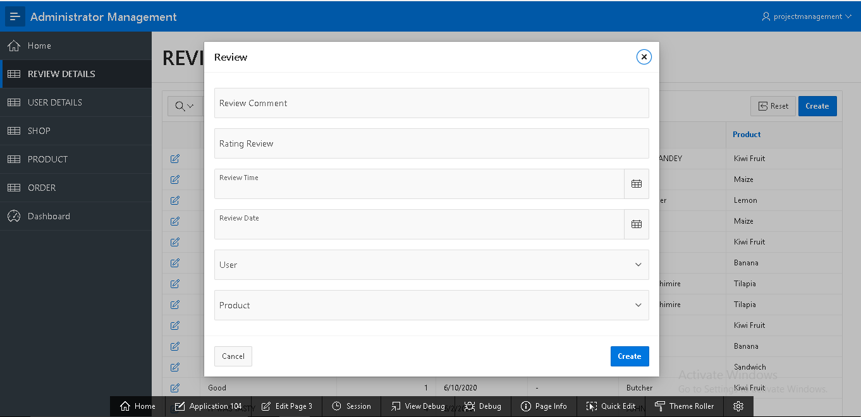

By filling this empty field and clicking on “create” review can be done

**Update Review**

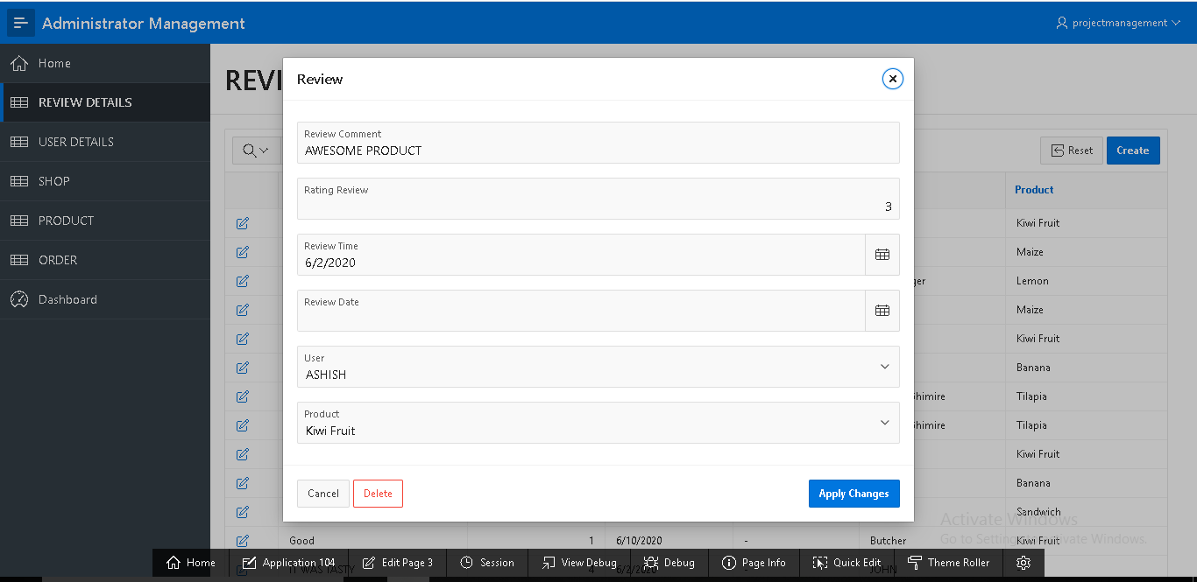

By clicking on “Apply changes” review can be updated

**Delete review**

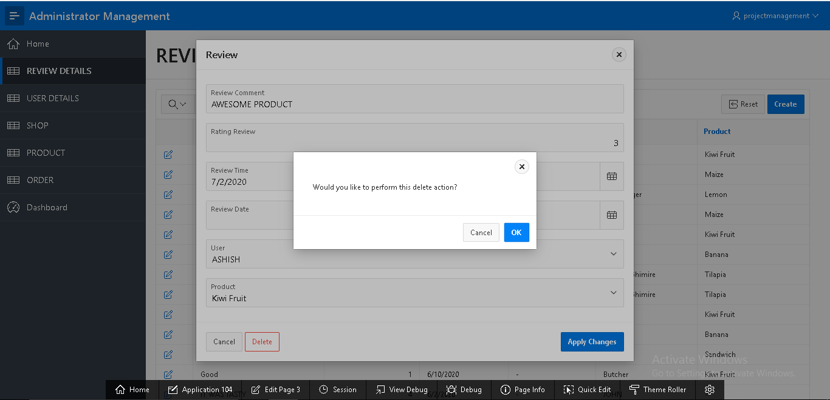

By clicking on “ok” review can be deleted

**Sign out**

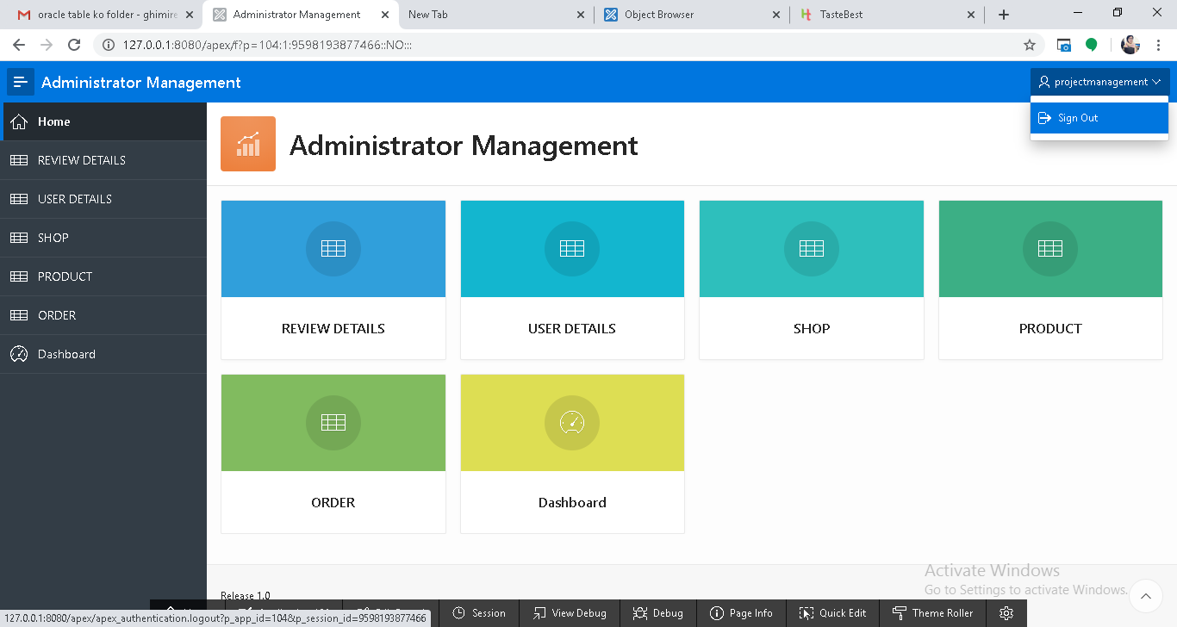

Admin can sign out by clicking on “sign out” on top right corner